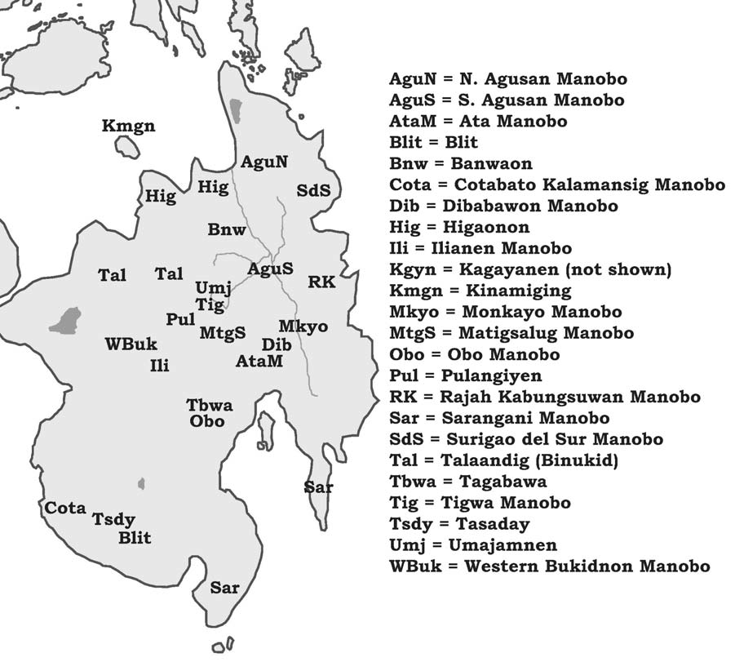

***2.7.2. Manobo.*** *The Manobo subgroup consists of at least 19 languages spoken throughout central and eastern Mindanao. Elkins (1974, 1984) has addressed the entire group in great detail, while Zorc (1974a) and Harmon (1977) have addressed the position of Kagayanen (a geographically-distant member of the Northern Manobo subgroup) and Burton (1996) presents a study of borrowing relationships between various Manobo and Mansakan languages. Following Elkins plus Lobel’s subsequent work on the entire group (including languages for which data was unavailable to Elkins), the 19 Manobo languages can be classified into five branches: Northern, including Talaandig-Higaonon (a.k.a. Binukid), Kinamiging, Banwaon, and Kagayanen; Southern, including Tagabawa, Sarangani Manobo, Cotabato-Kalamansig Manobo and Tasaday; Core-Western, including Obo Manobo, Ilianen Manobo, Western Bukidnon Manobo, and Pulangiyen Manobo; Core-Central, including Ata Manobo, Matig Salug Manobo, and Tigwa Manobo; and Core-Eastern, including Agusan Manobo, Rajah Kabungsuwan Manobo, Umajamnon, and Dibabawon*